Electric Circuit Analysis

Lab 11

By Gabriel Emerson

Lab 11 is essentially a lab using one DC source, and one AC source, then after doing a complete analysis of them separate, add them together to test the Law of Superposition. Superposition is an analysis technique that is done in a few steps. Remove all sources except one and solve for each node. Then, do the same for the next source, and goes on until there are no more sources. Then add up the values from each source, to give you the final answer of the entire circuit. This is done in Lab 11.

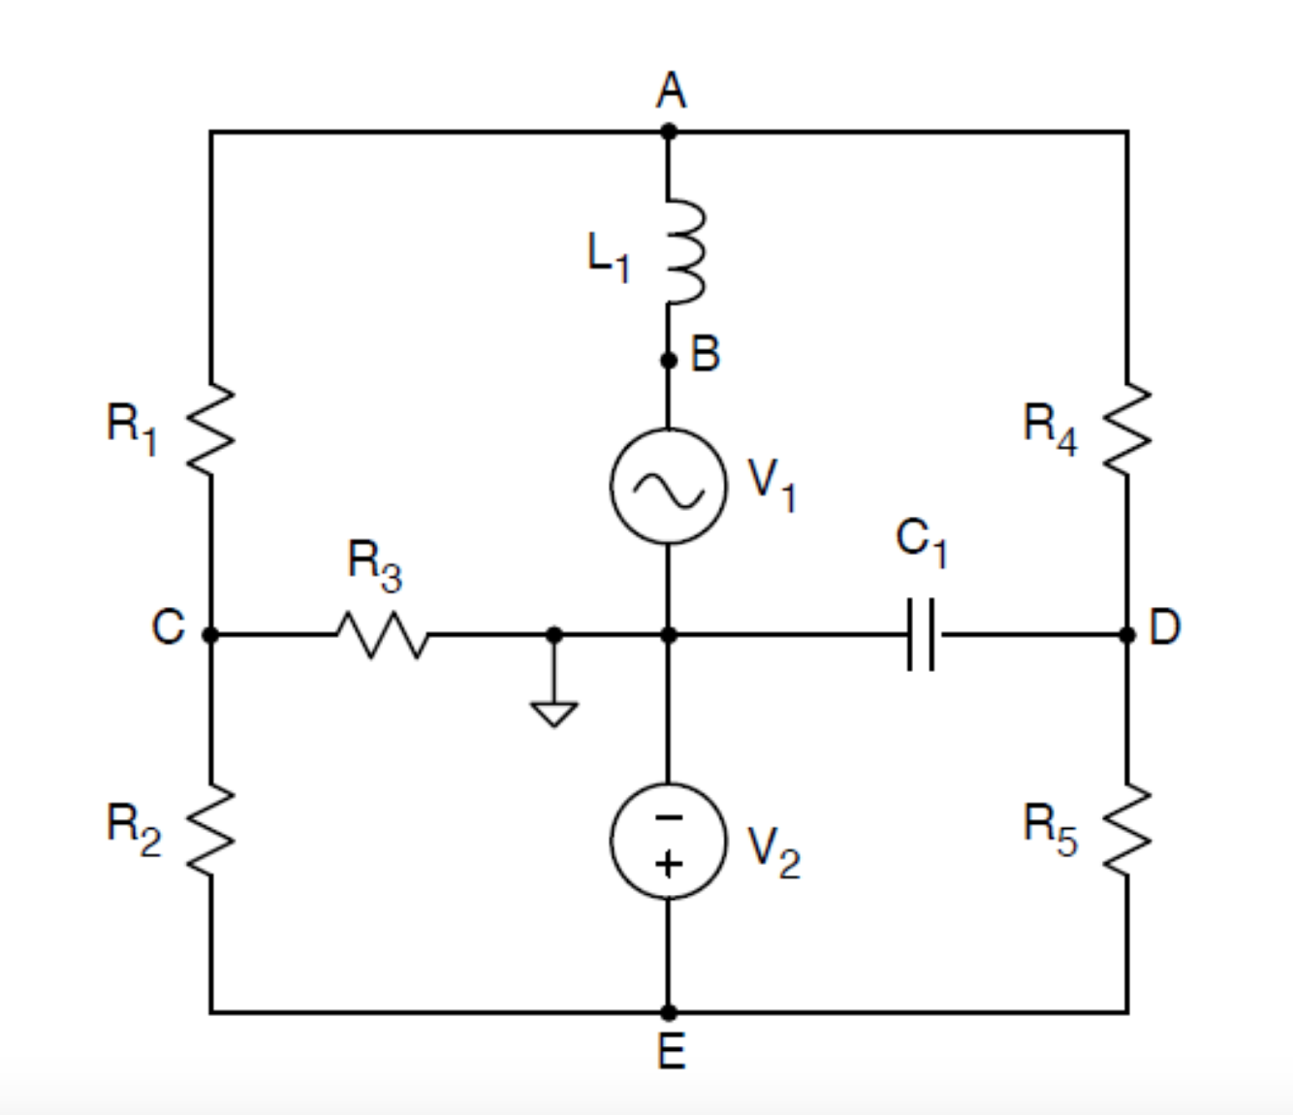

(1)

This is the circuit that we will work with.

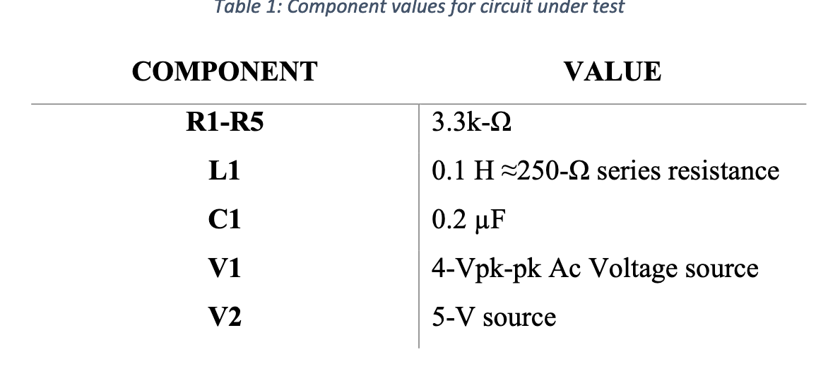

(2)

And these are the values for each component in our circuit.

First start with the DC source. Perform DC analysis to find theoretical values for the circuit. Then, find the actual values for each node.

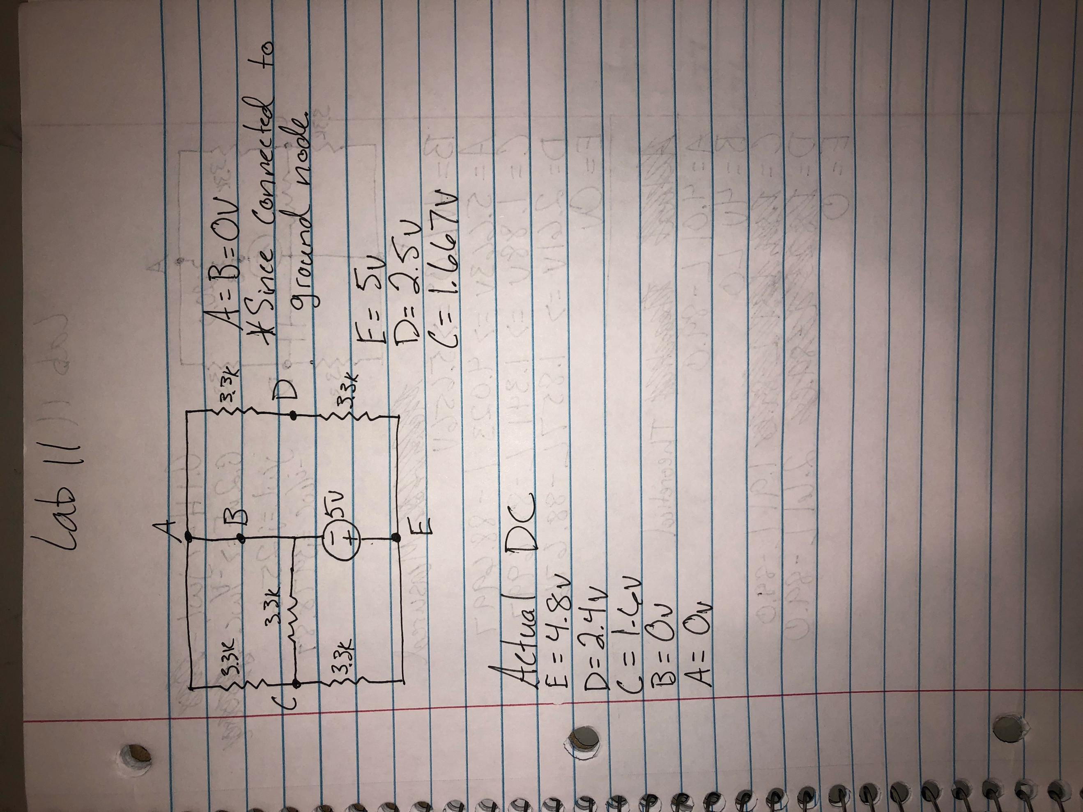

(3)

The breadboard circuit looks like:

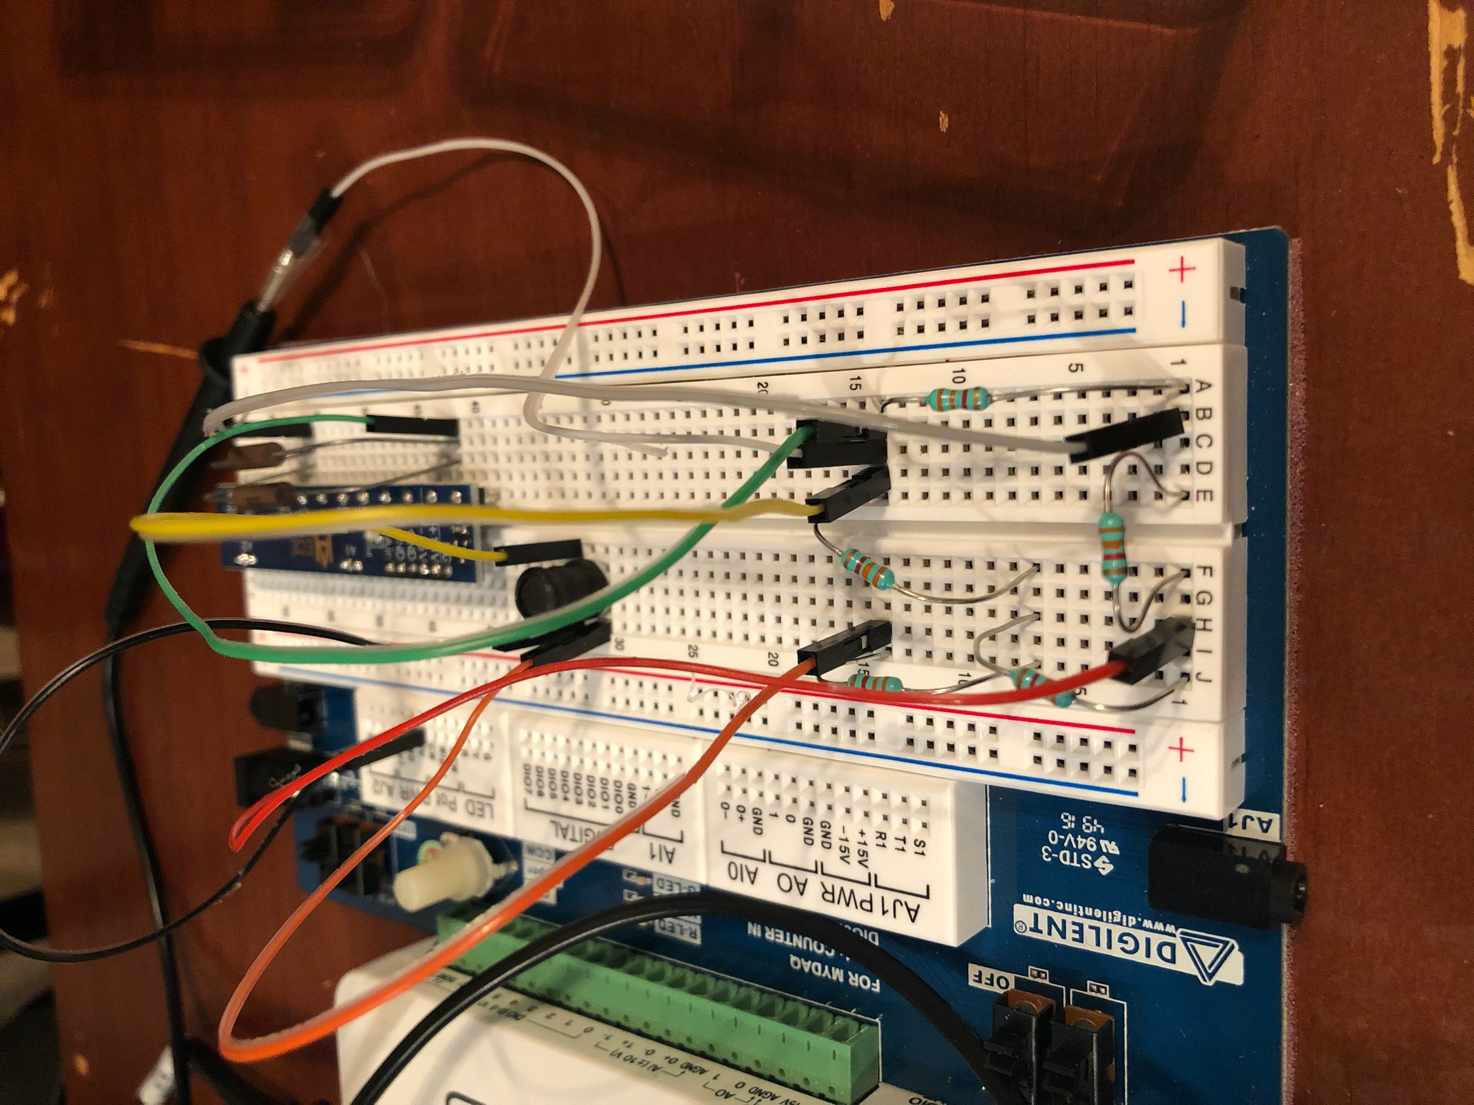

(4)

Then, take out the DC source, and put the AC source in and repeat the same steps. Find the theoretical and actual values for each node.

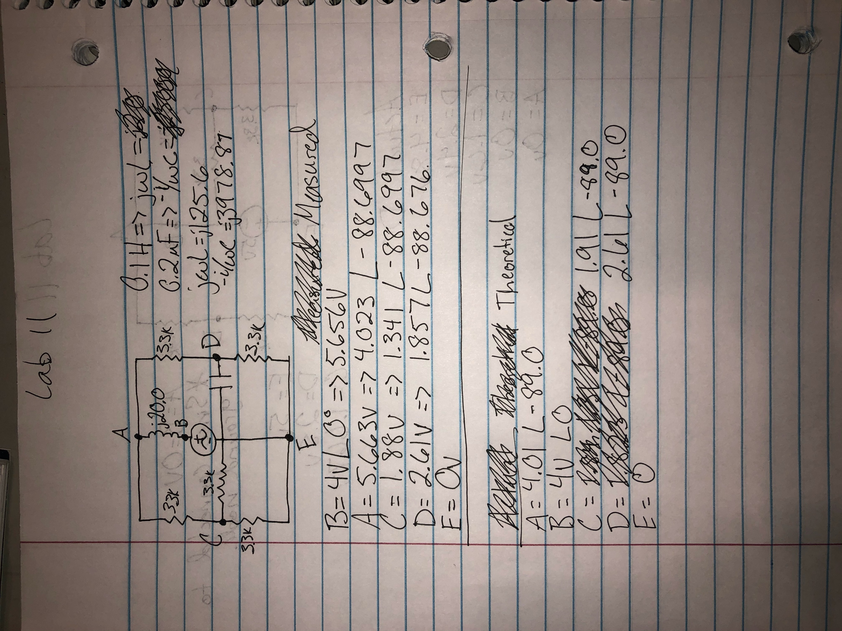

(5)

The breadboarded circuit looks like:

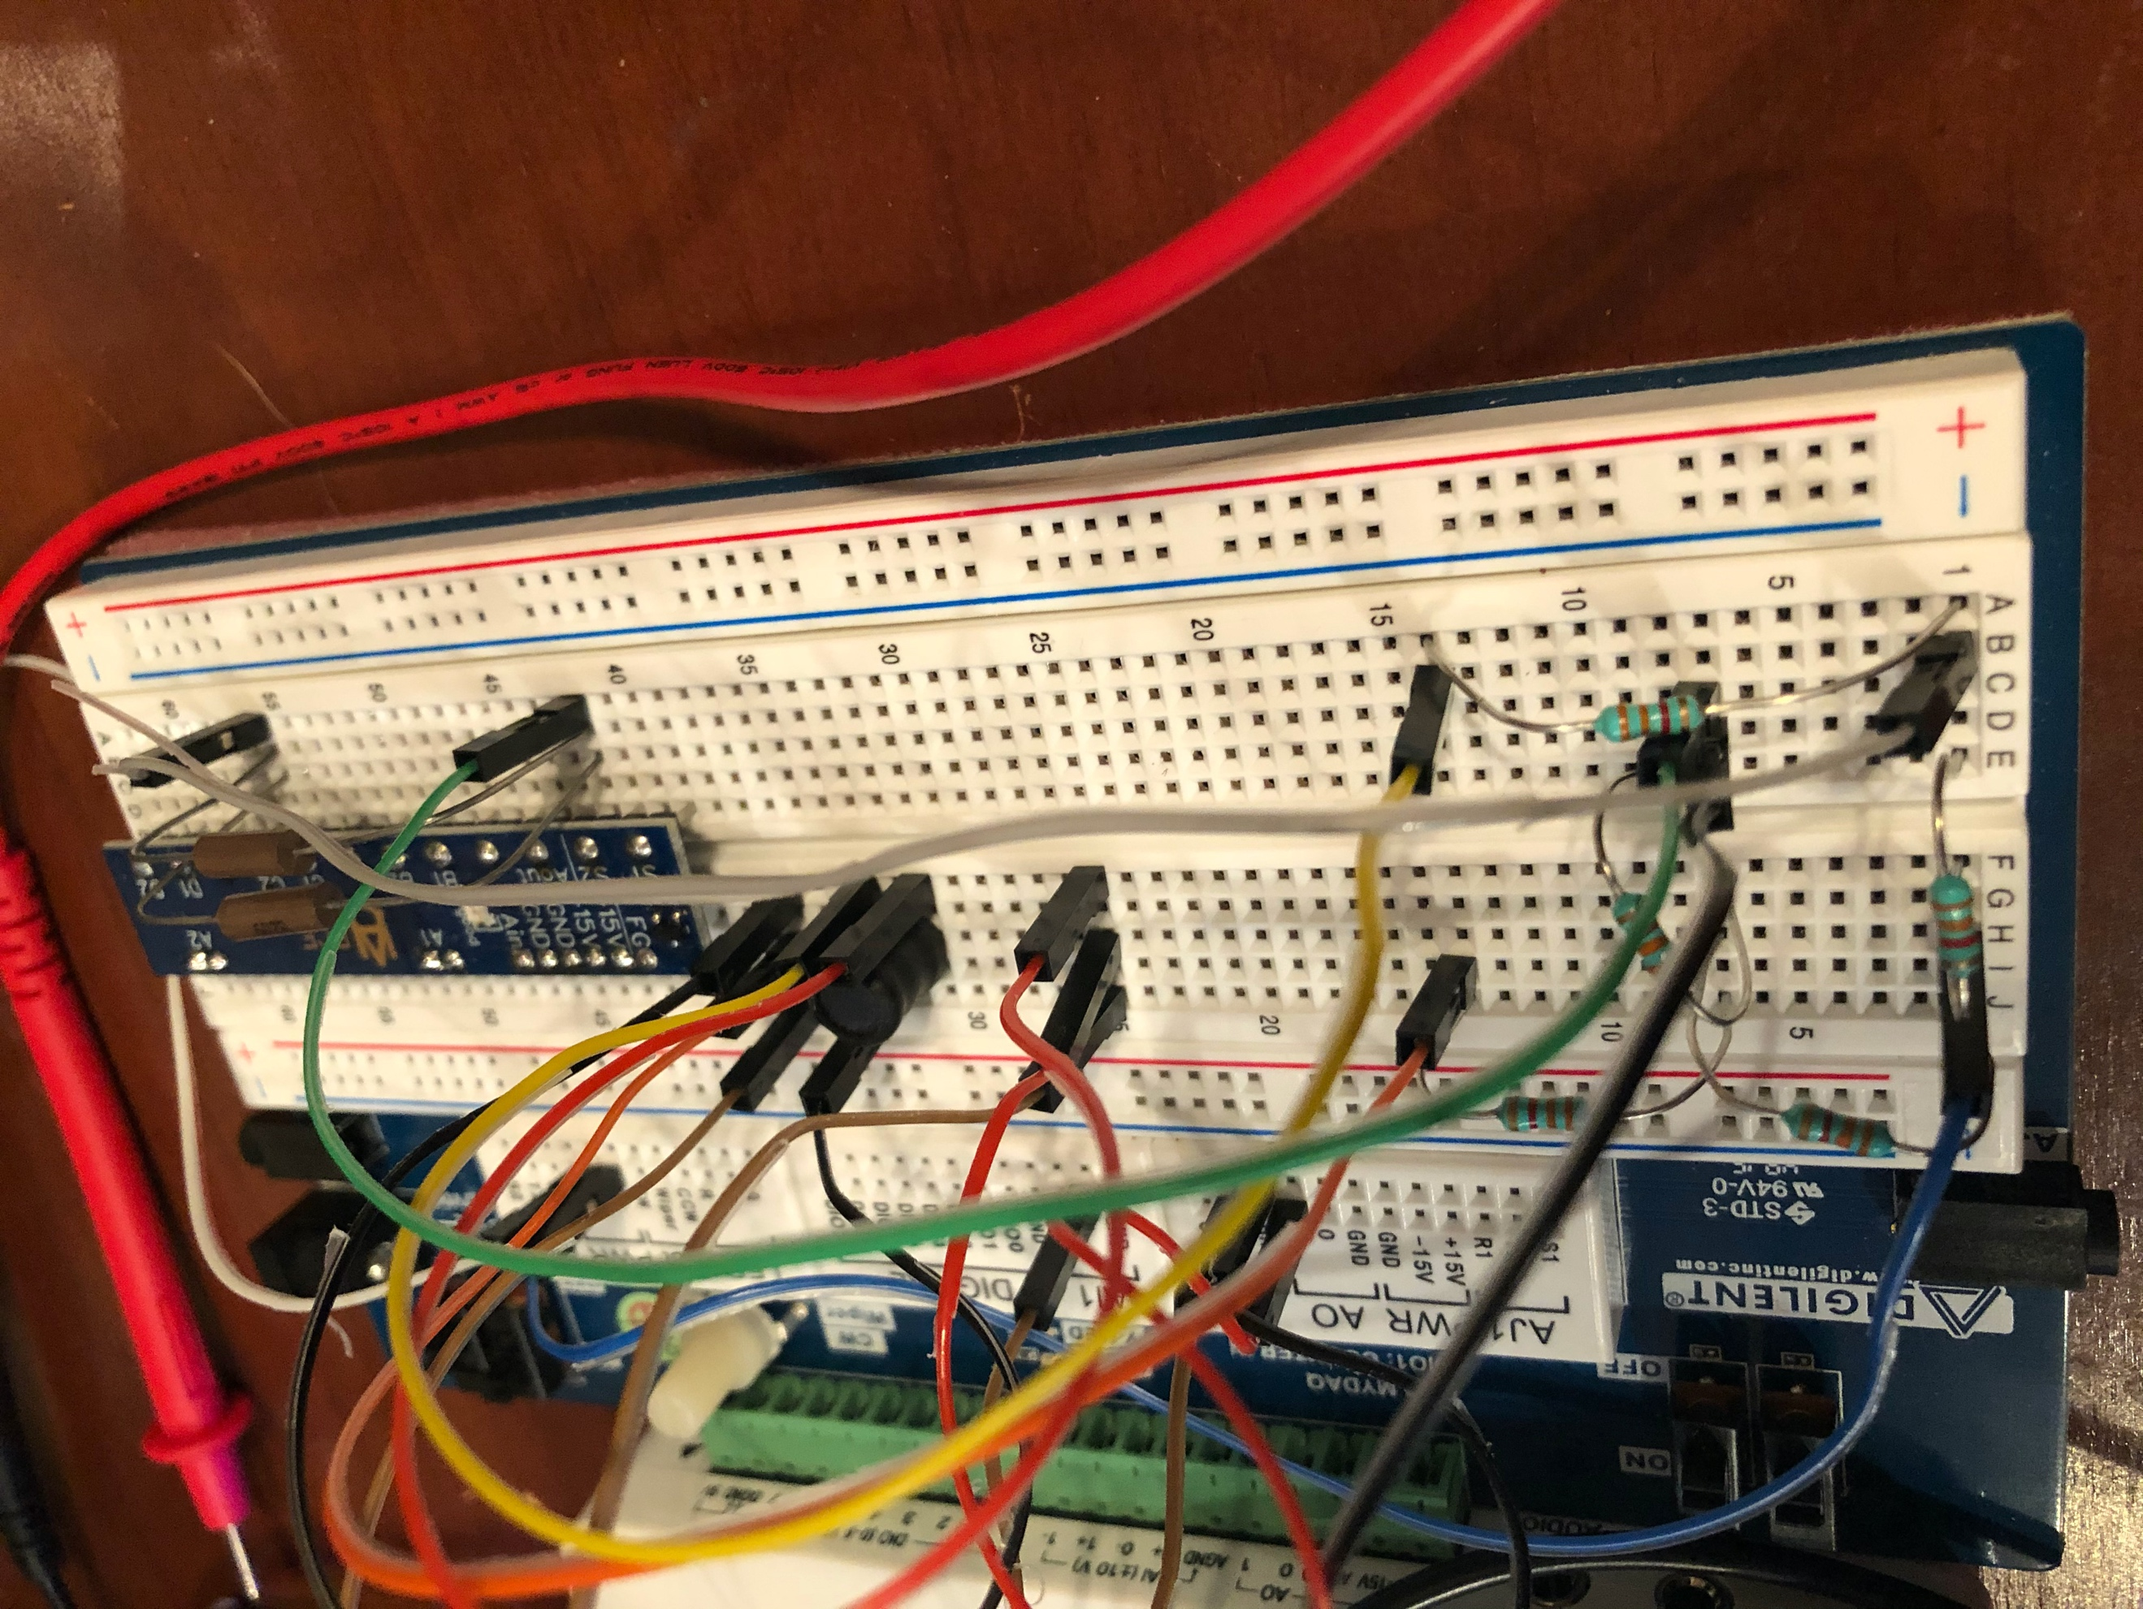

(6)

These were the oscilloscope measurements:

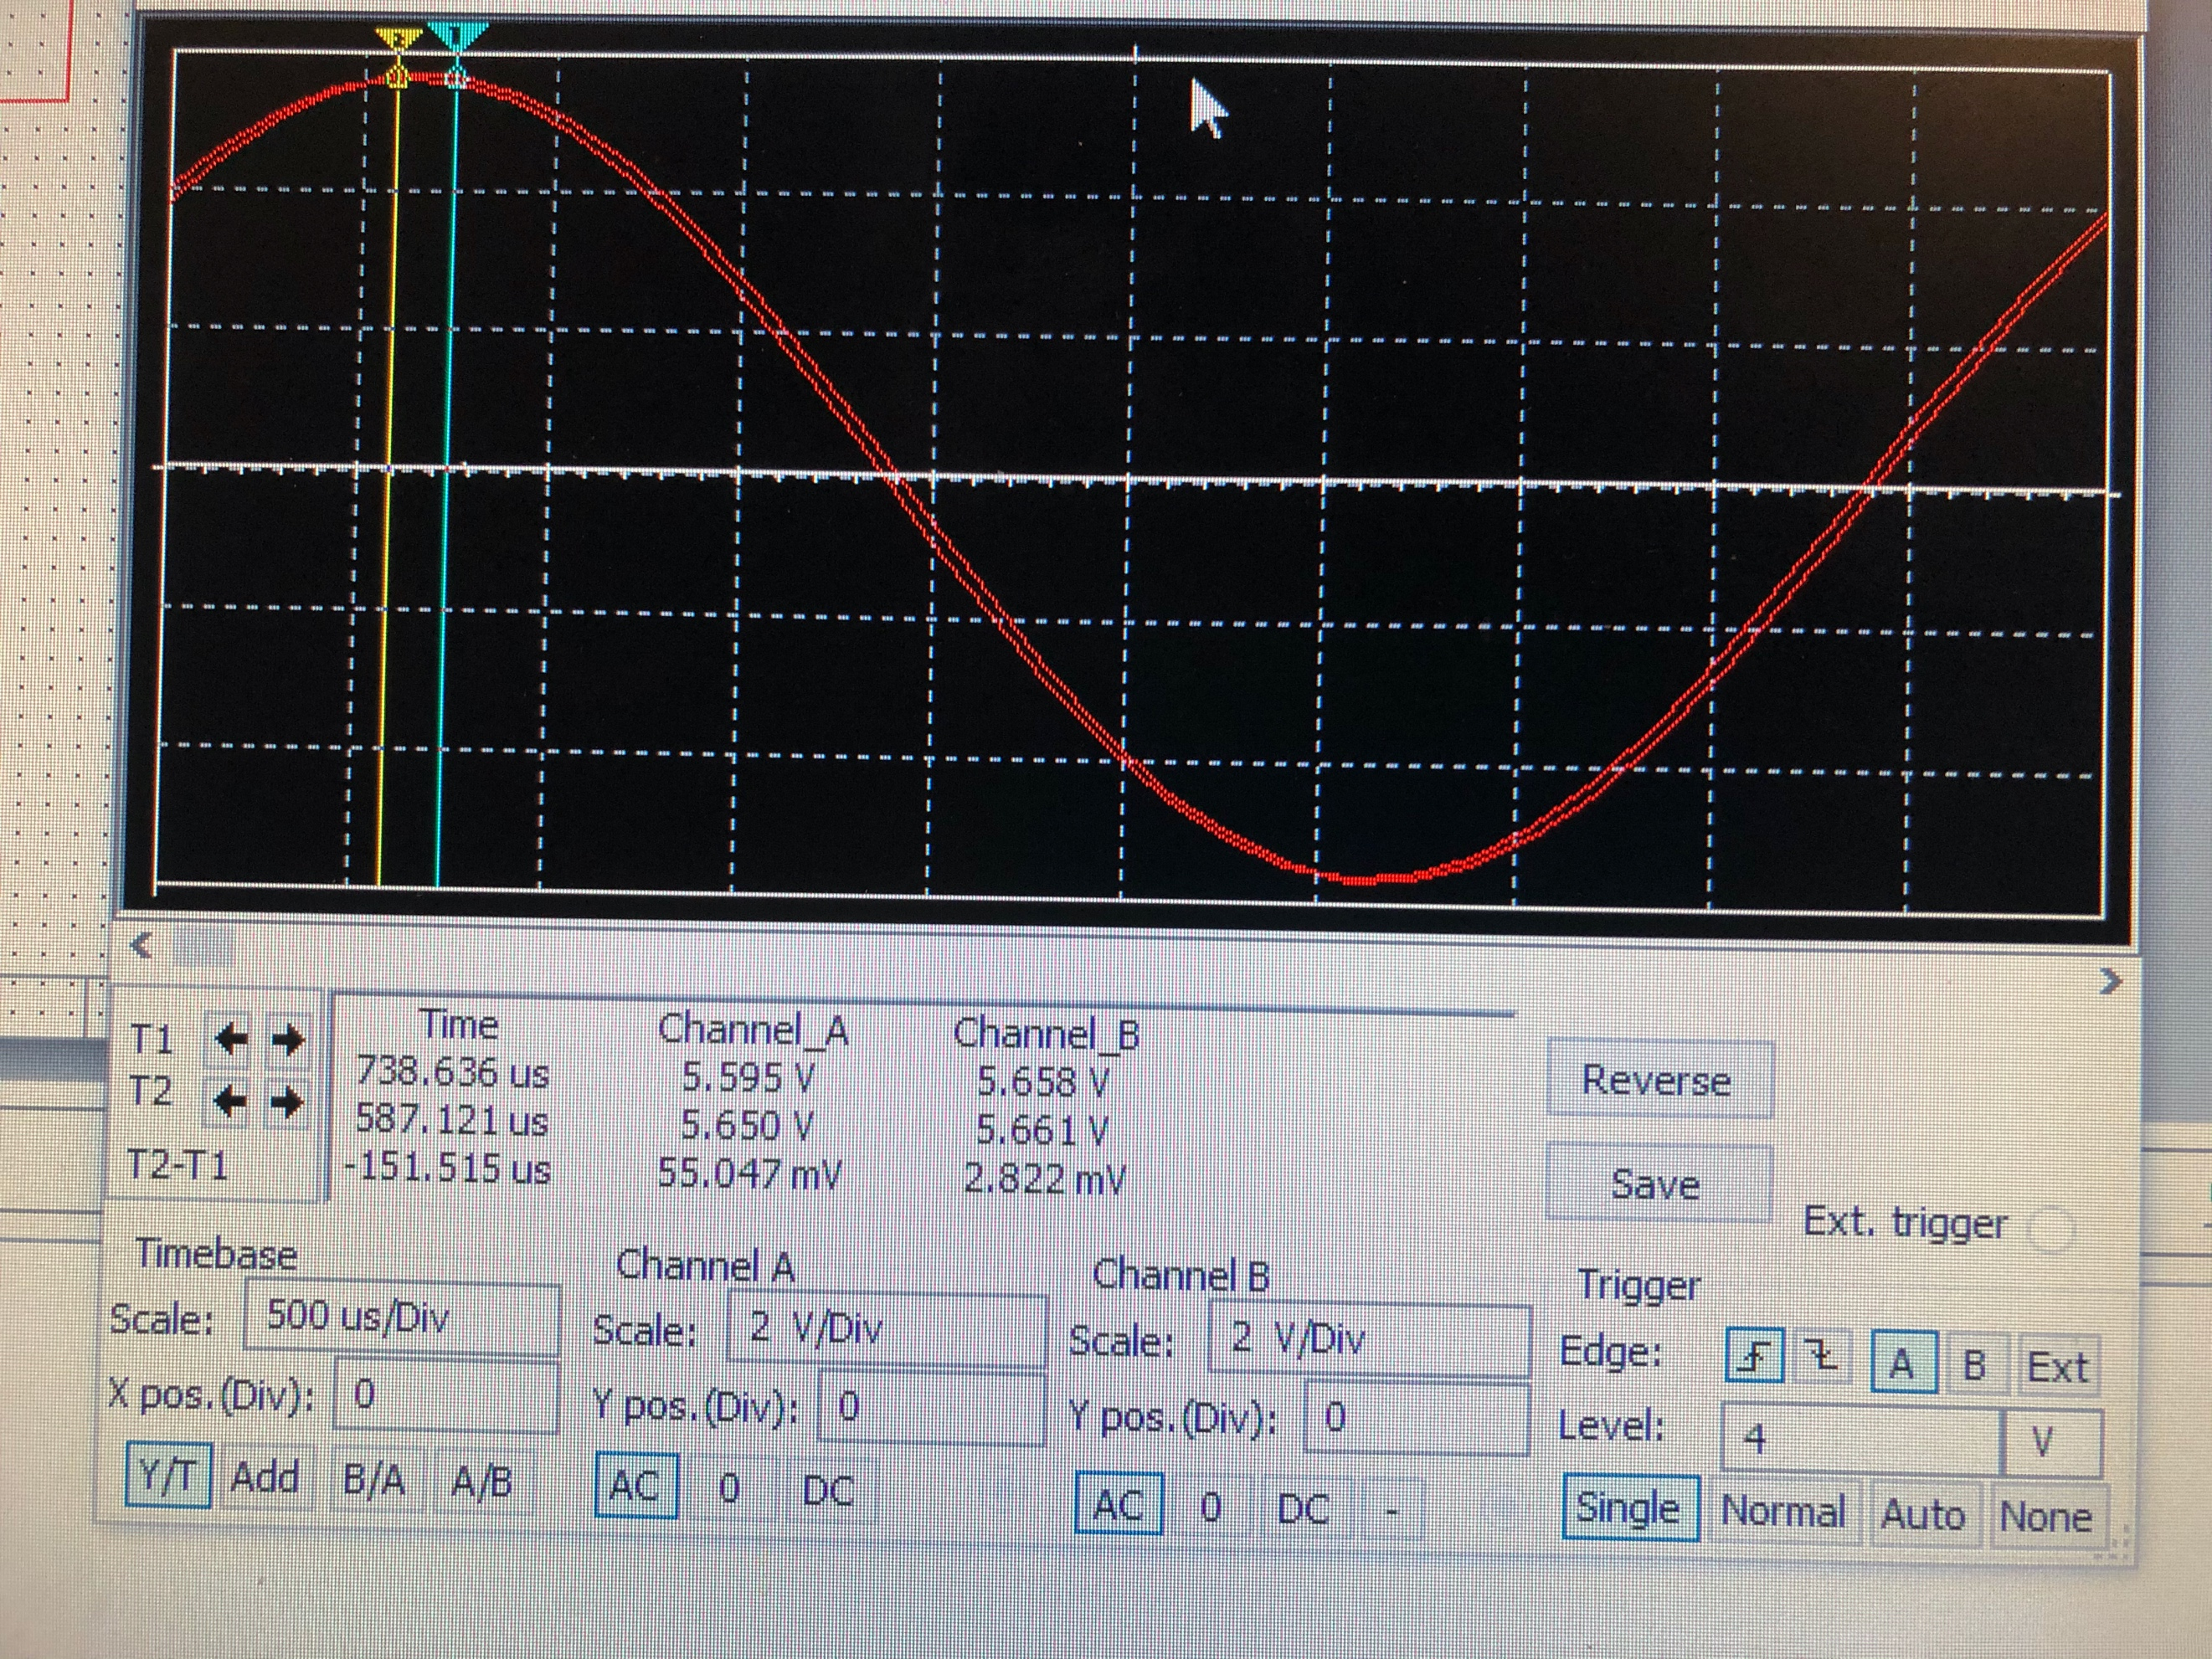

(7)

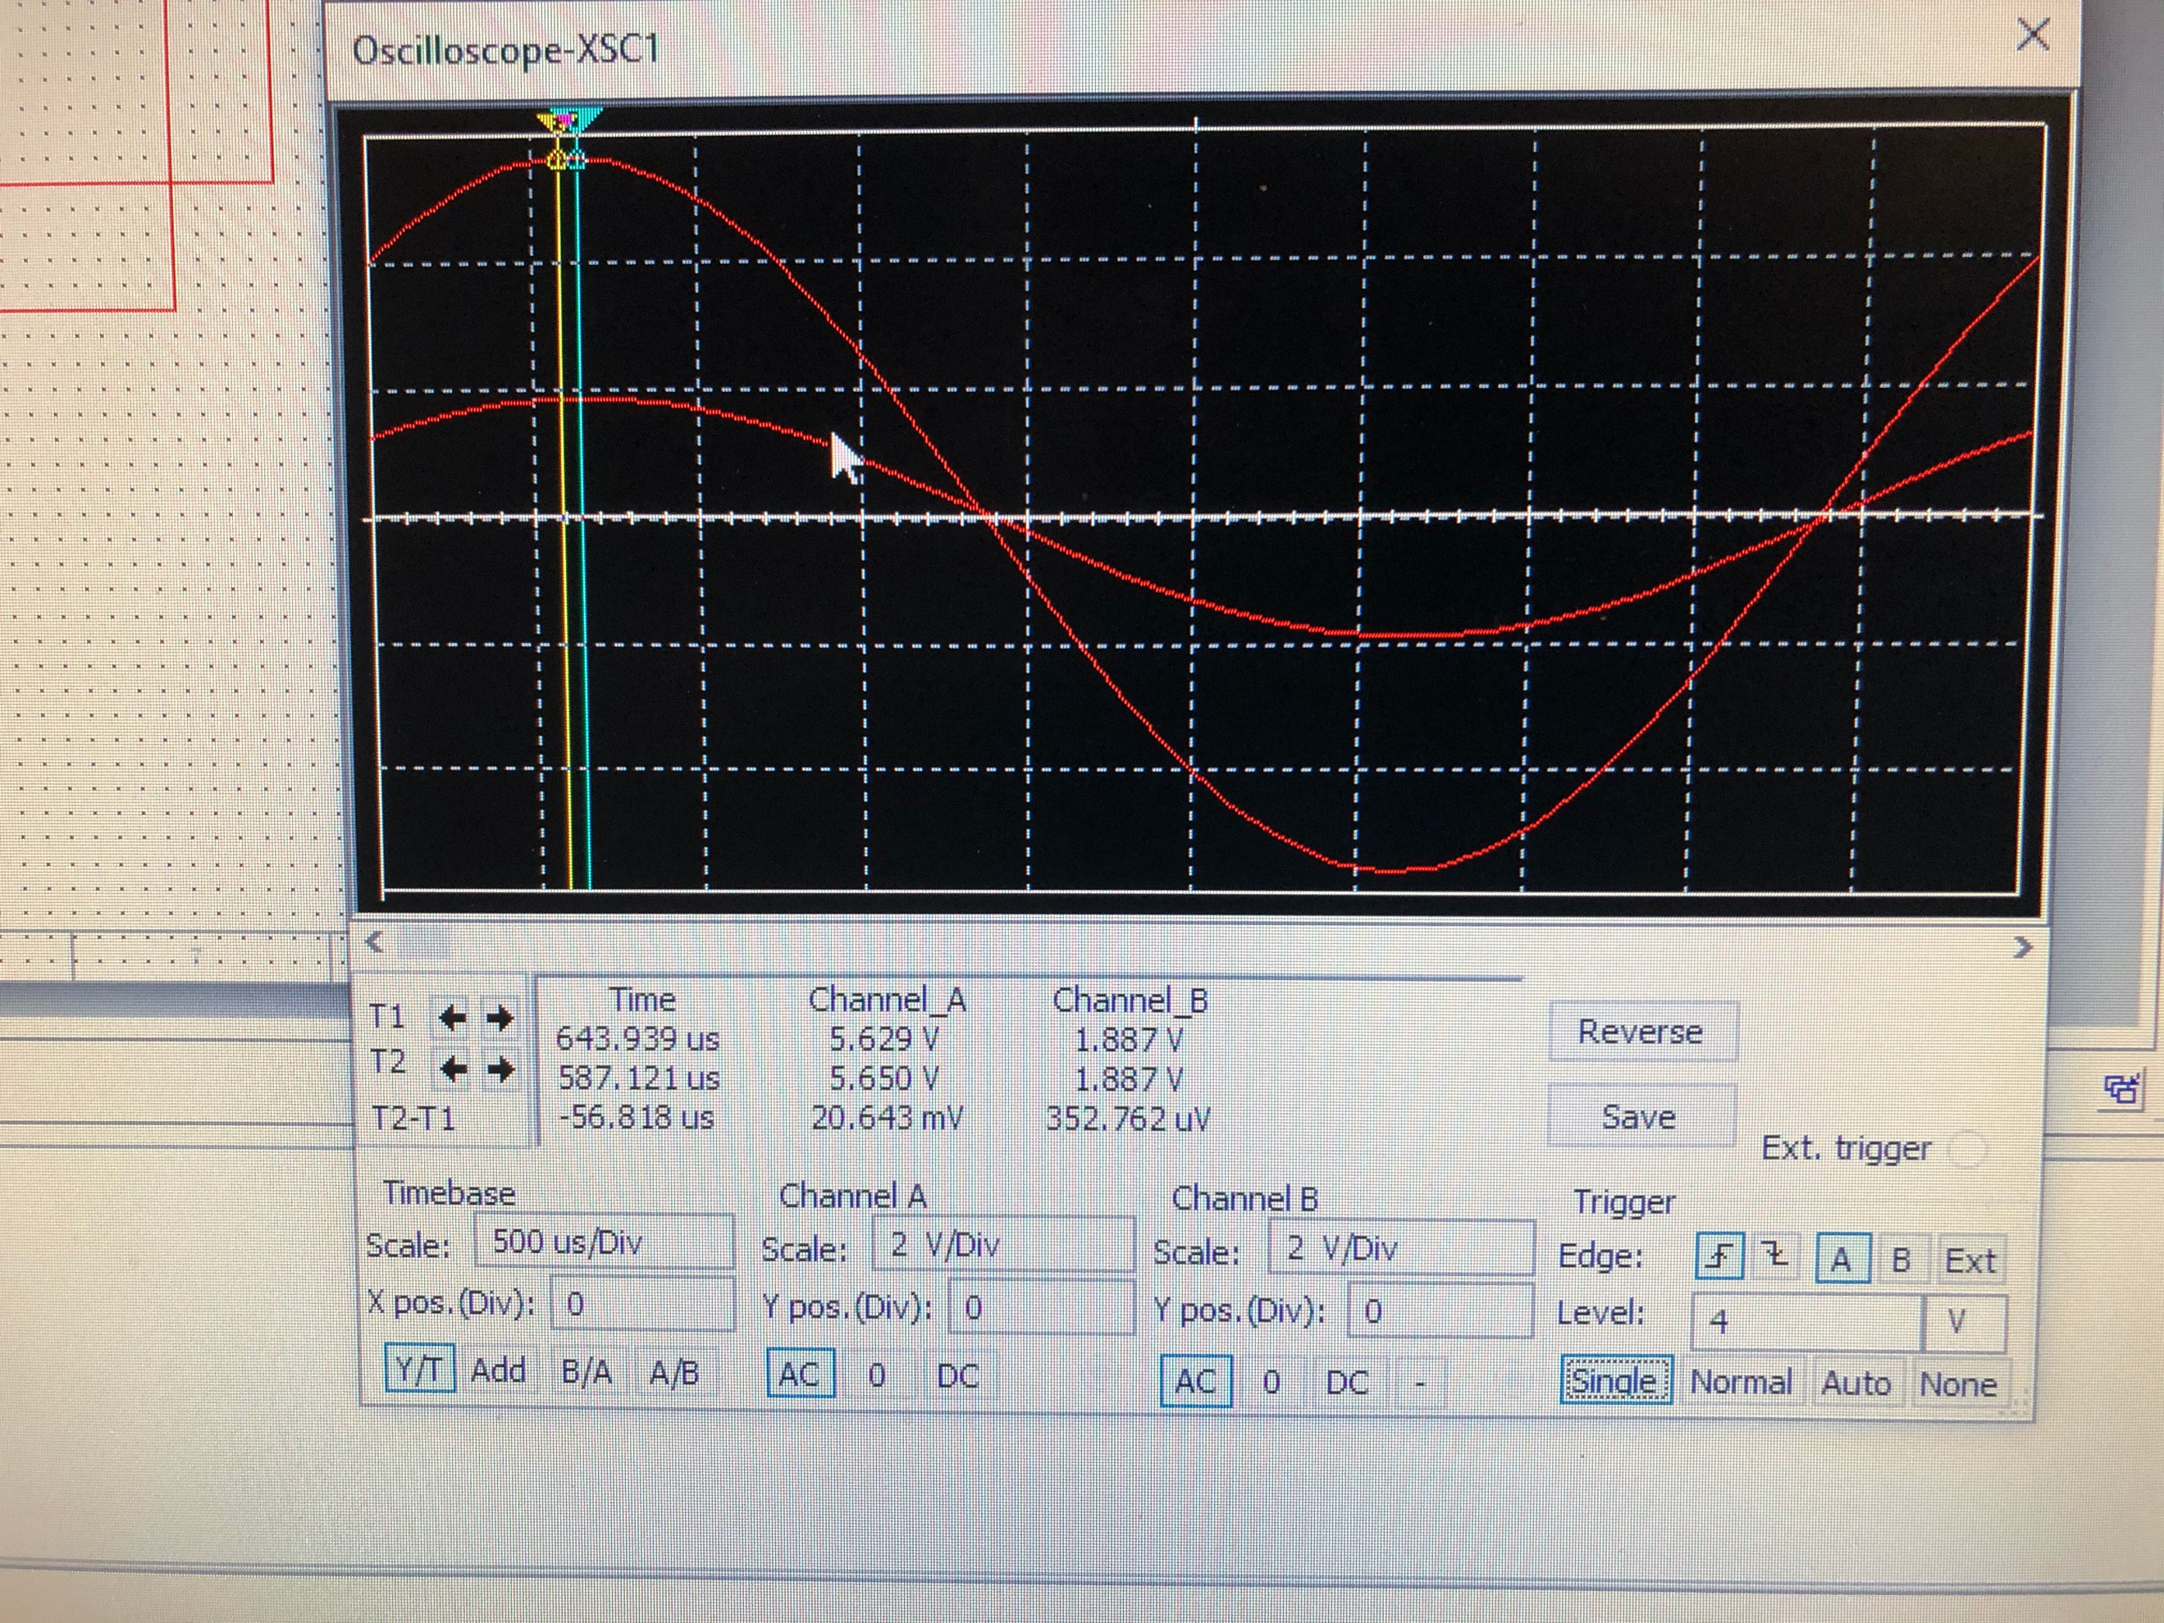

(8)

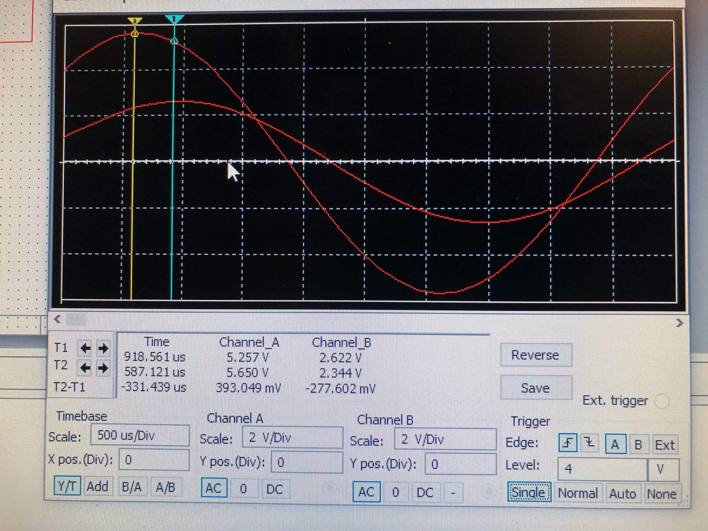

(9)

Then, after solving using either source, add up the values to get the overall value for the circuit. This is the main idea behind Superposition.

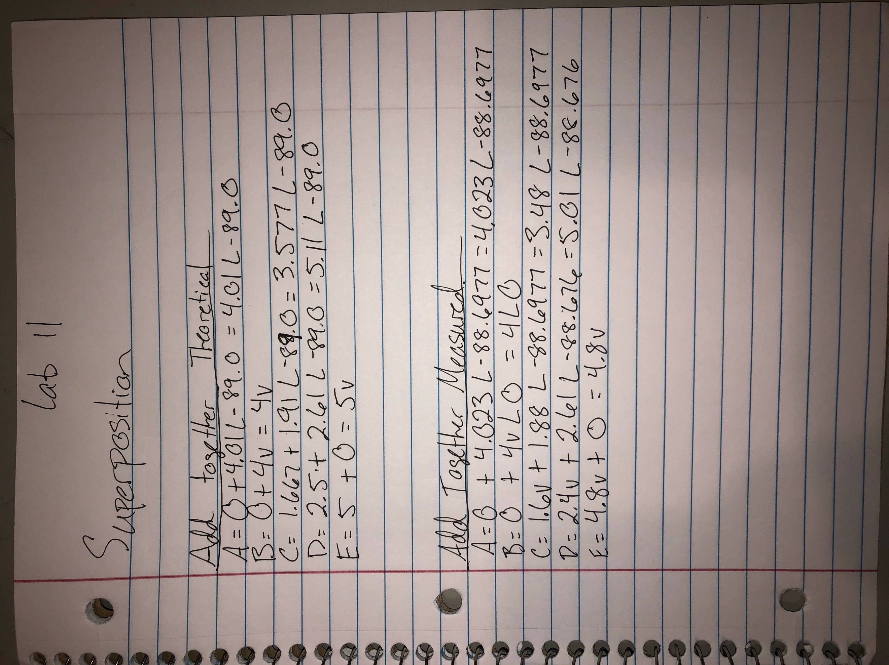

(10)

The Breadboarded circuit looks like:

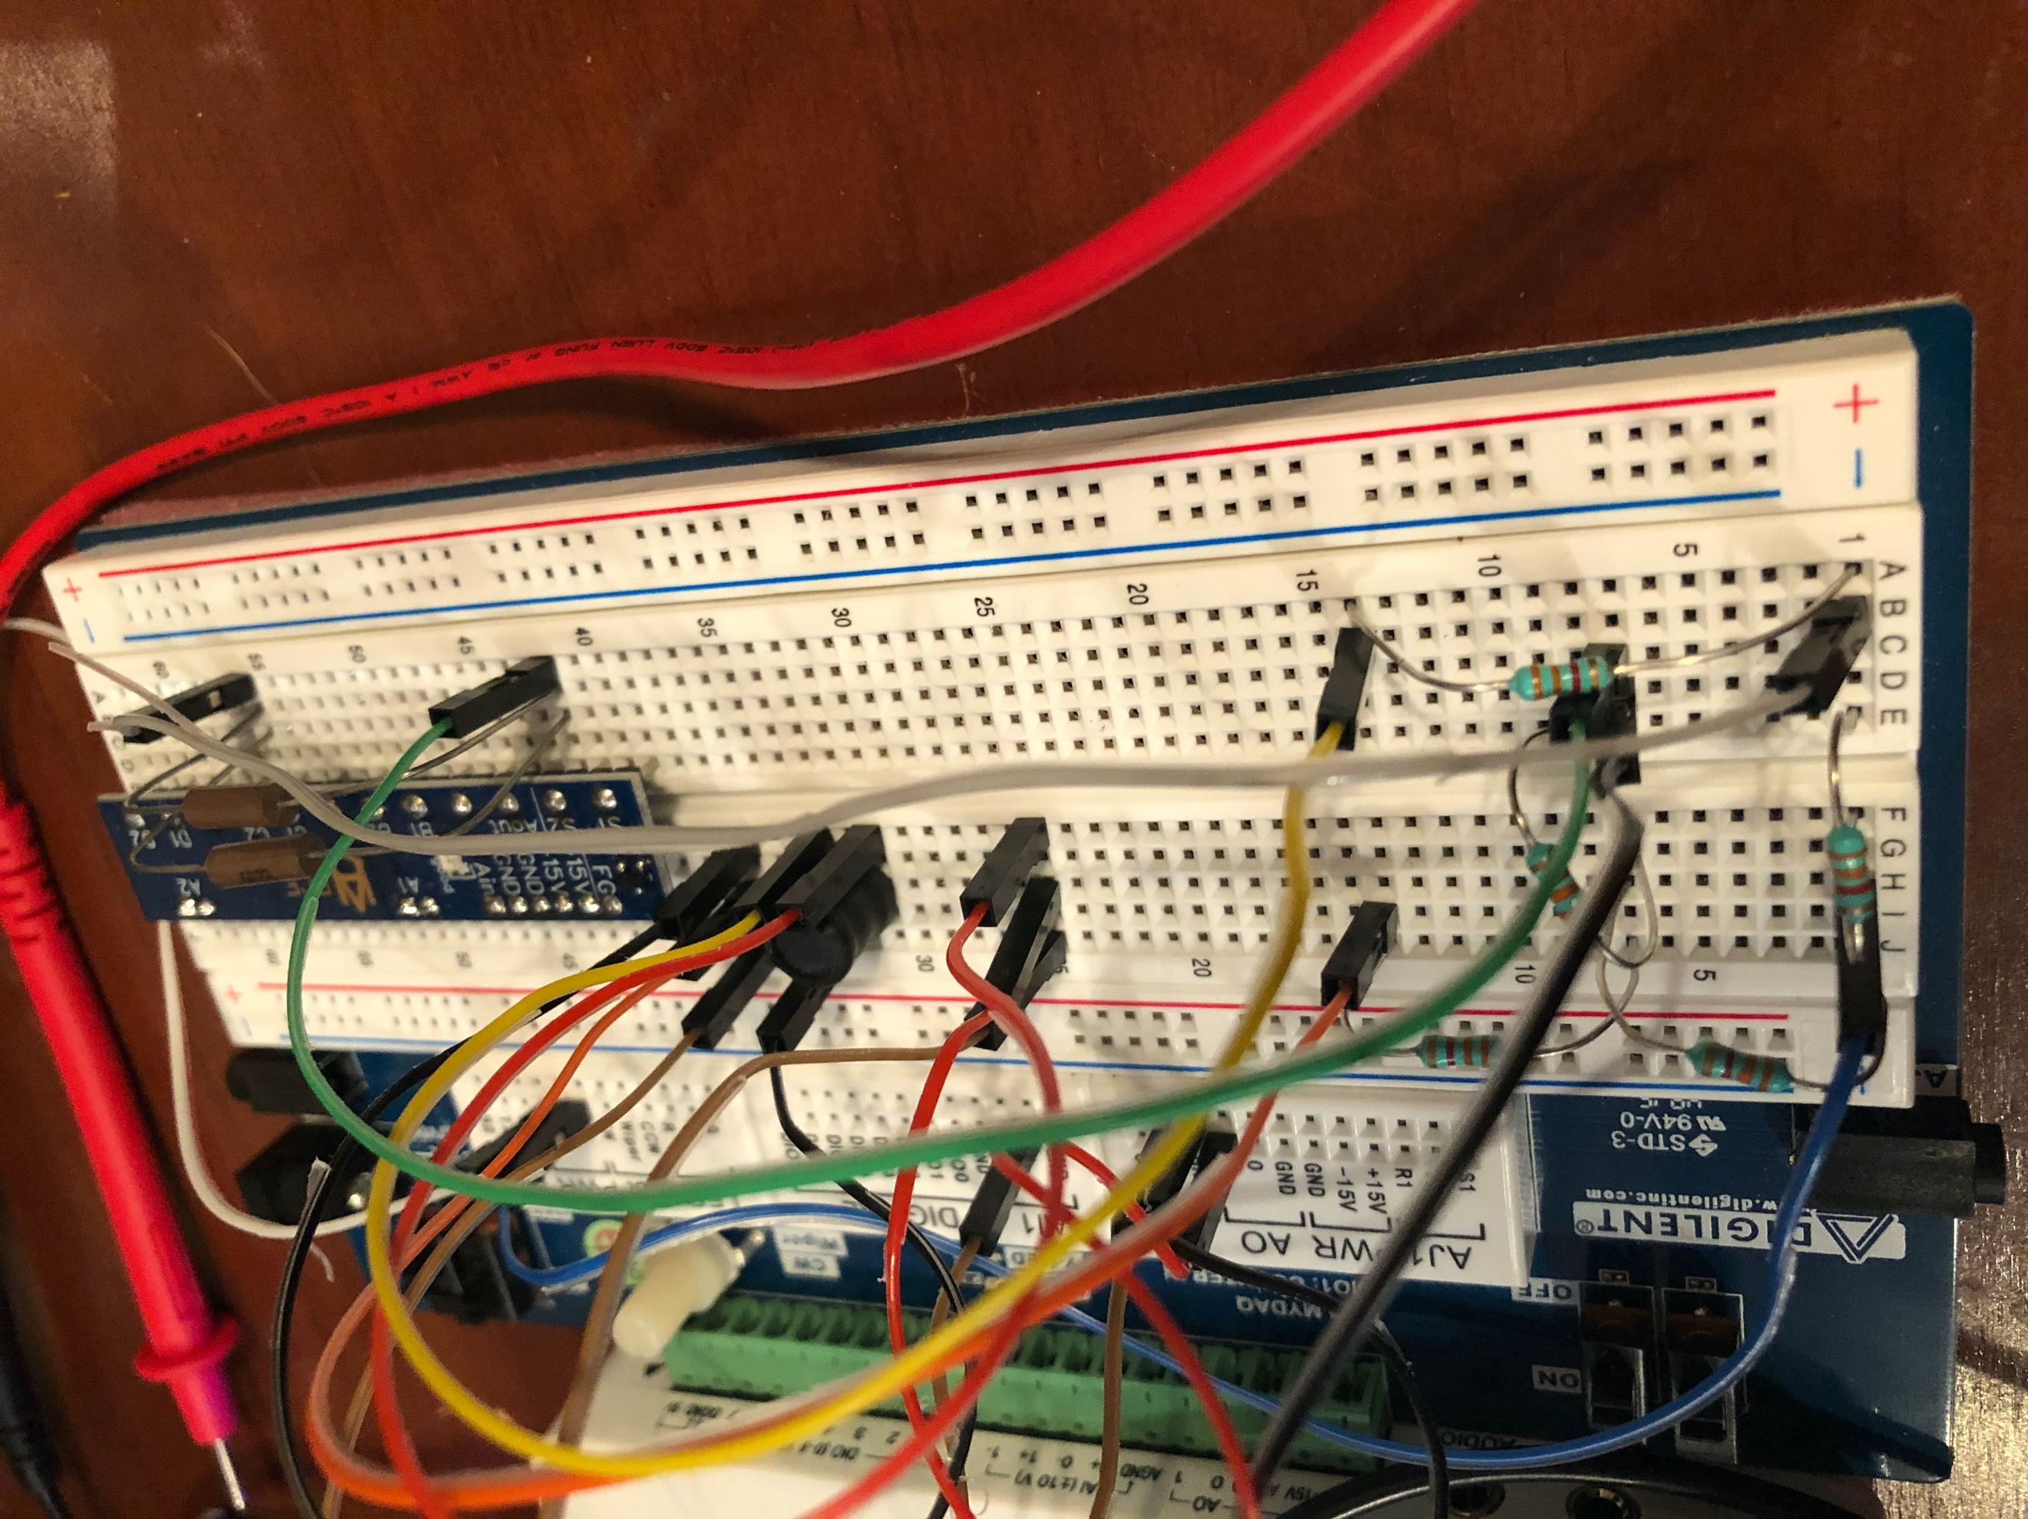

(11)

And record the final values for each node A-E.

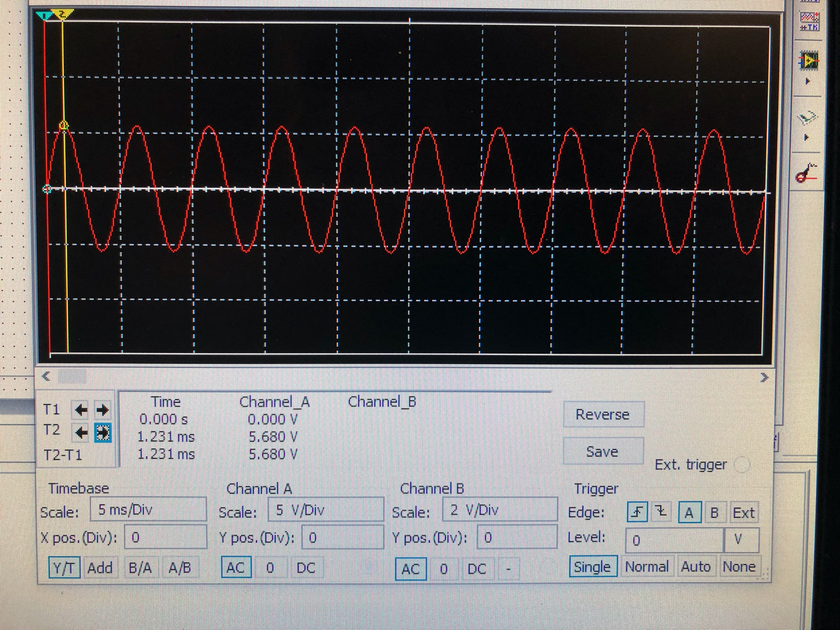

(12)

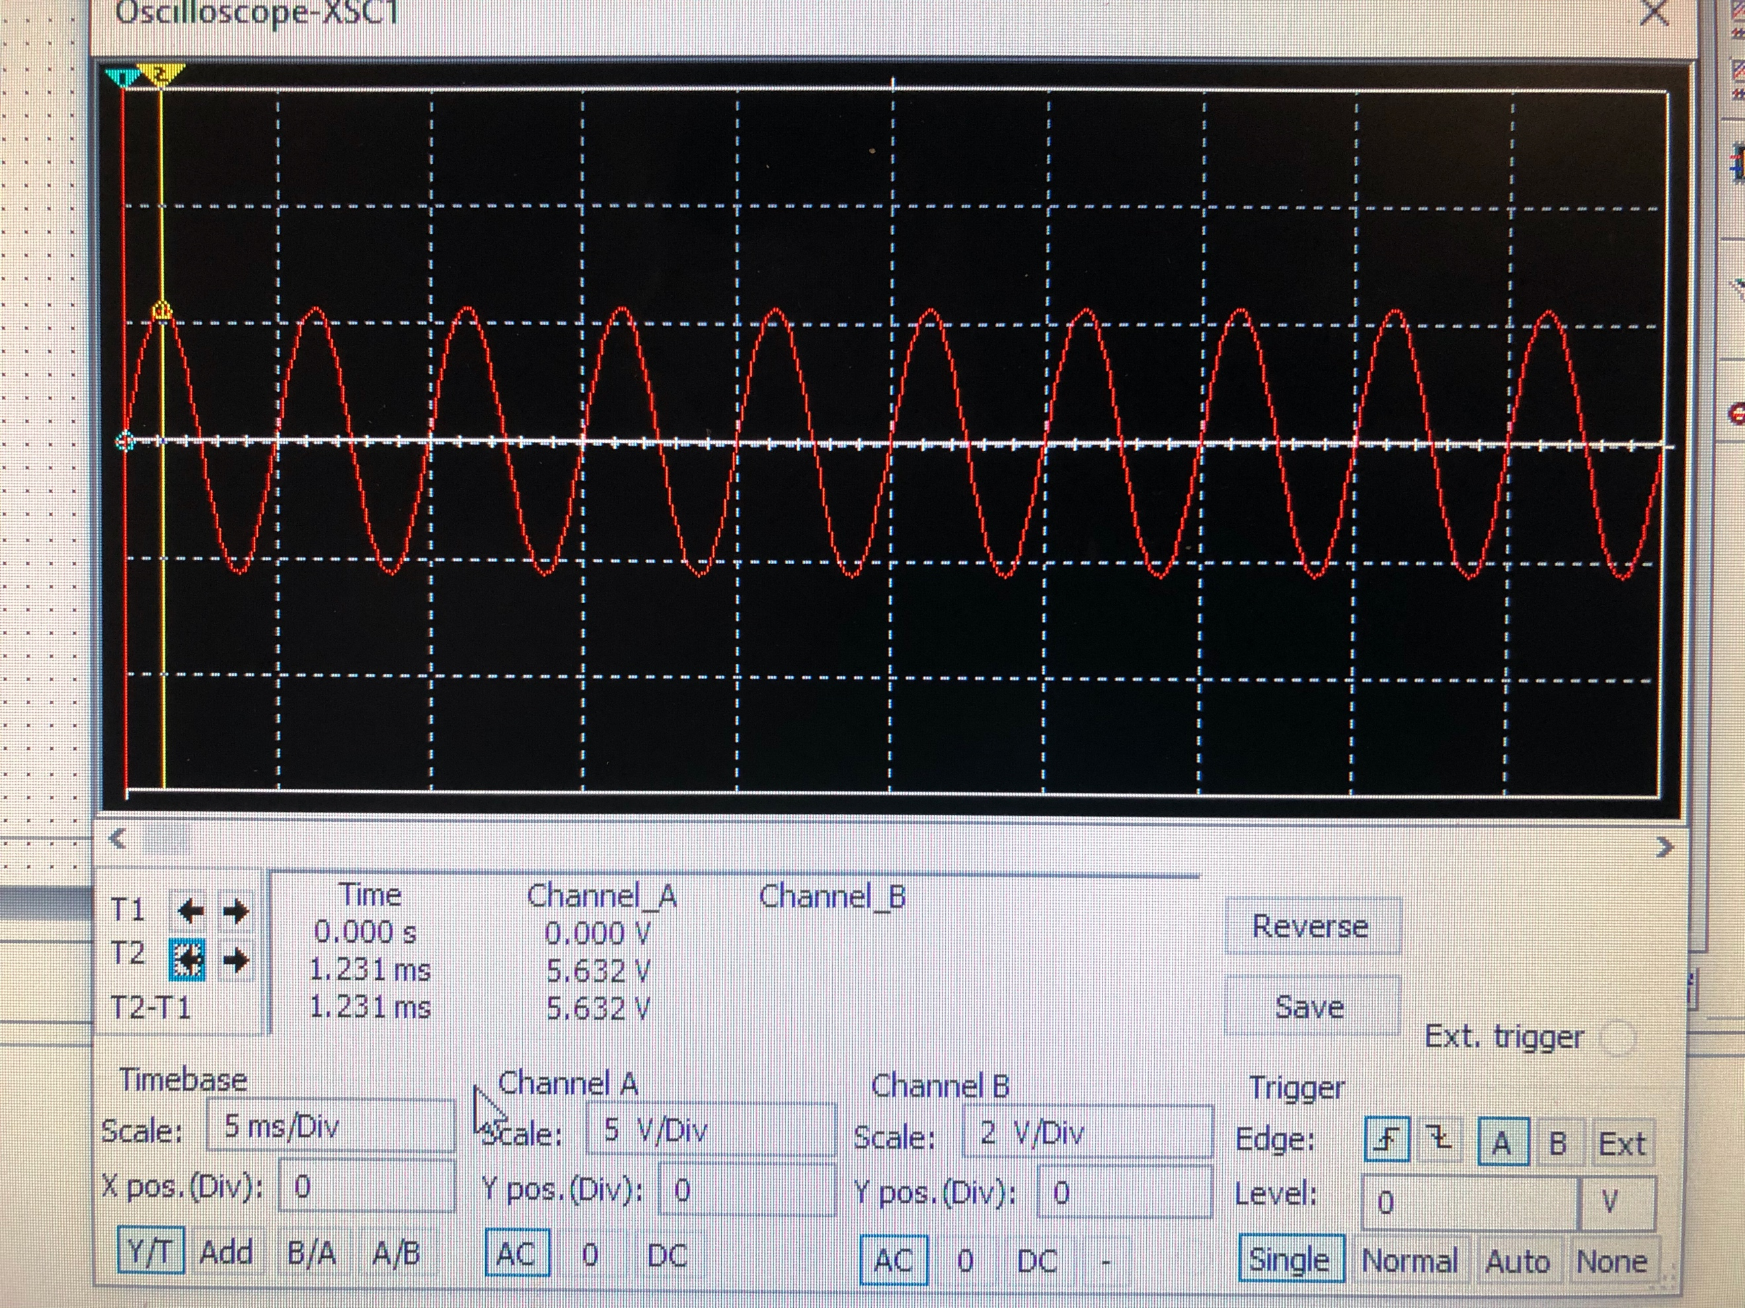

(13)

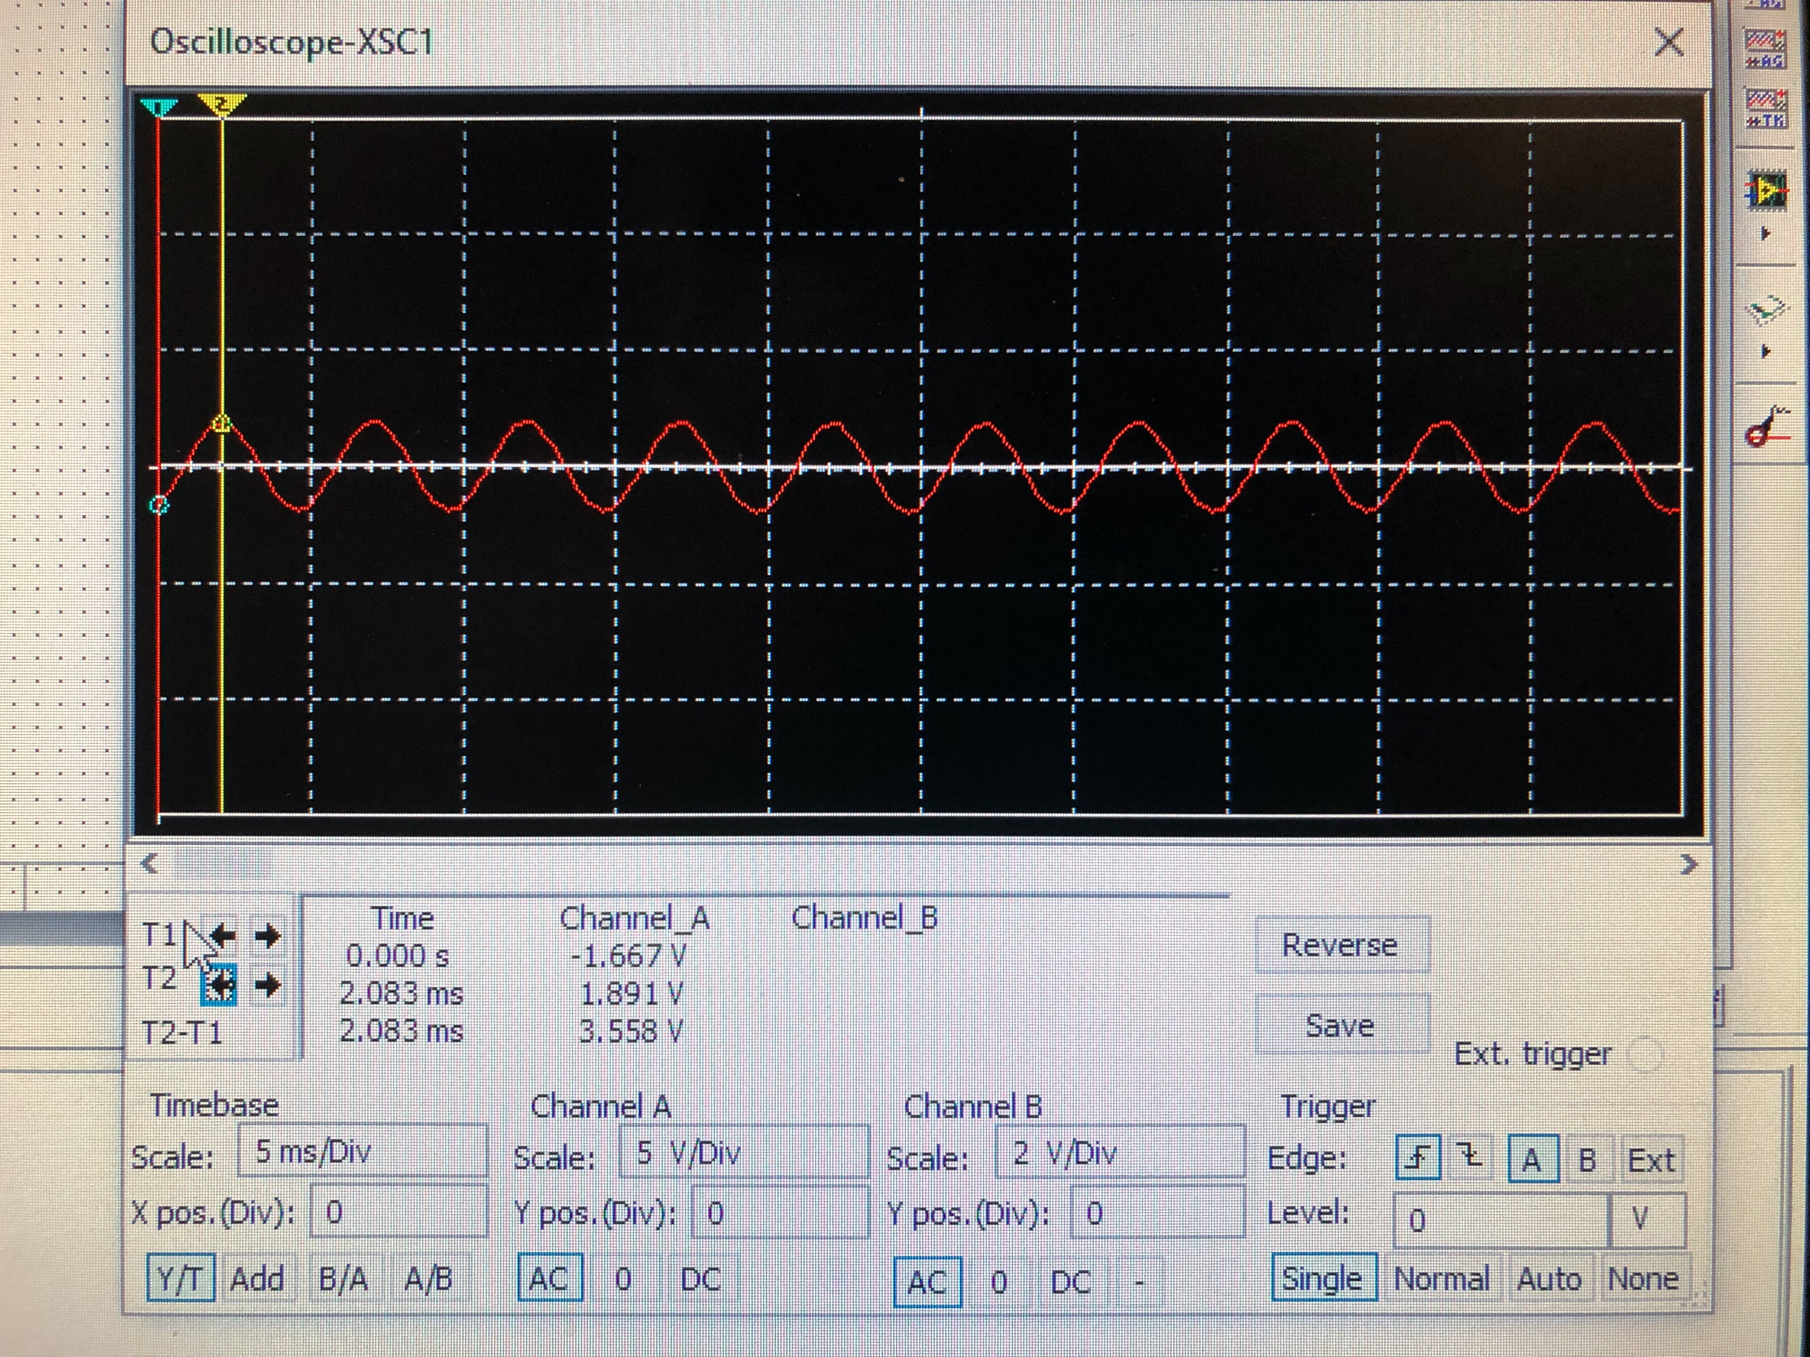

(14)

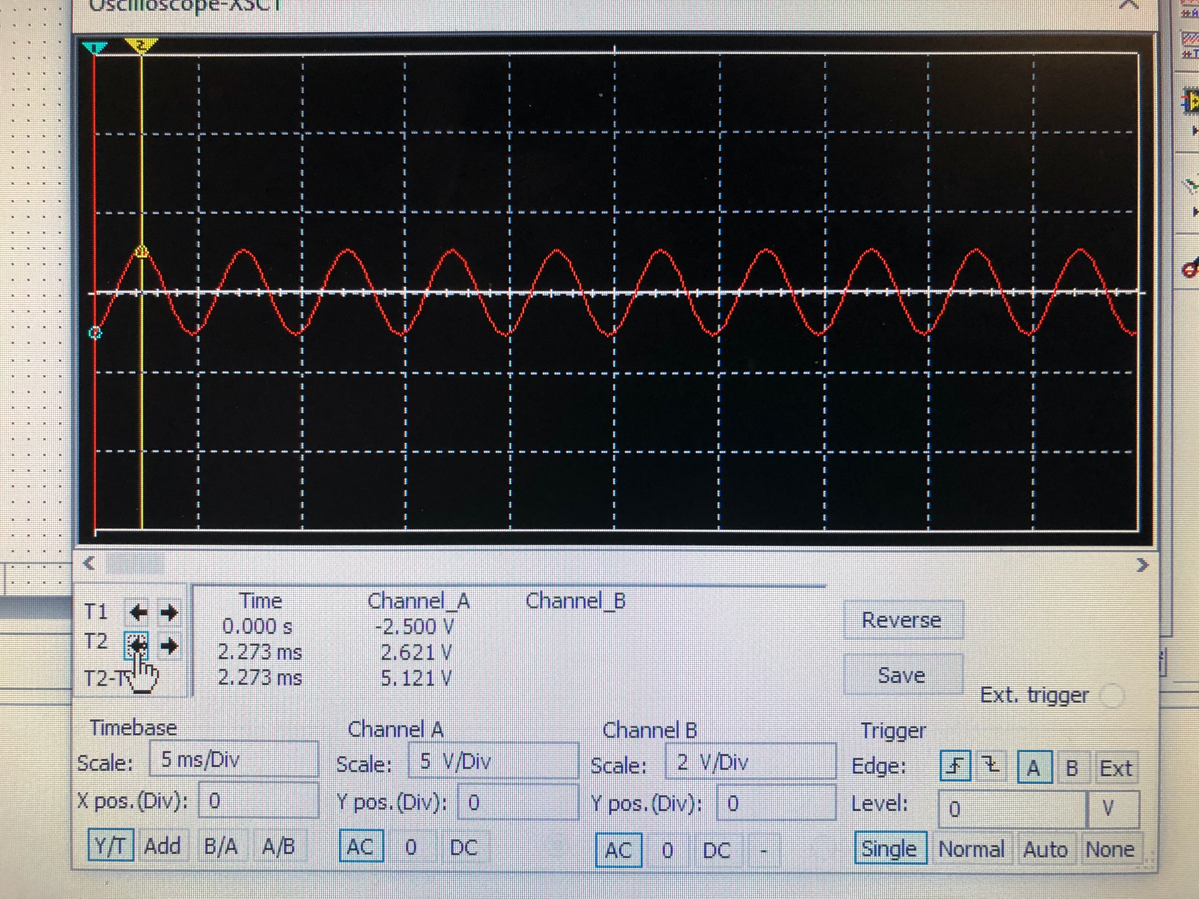

(15)

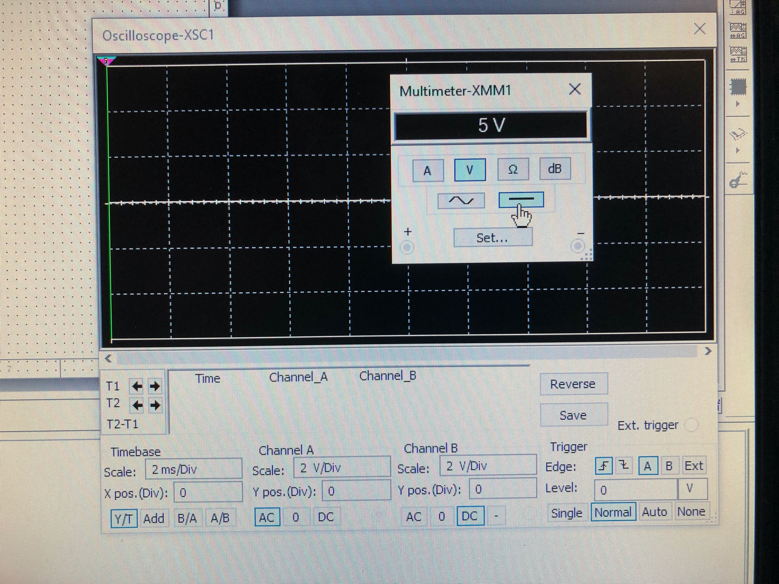

(16)

There is no AC value on Node E, so I had to get a DC multimeter when checking my numbers with both sources. It does find the correct answer to be 5V.

Since these figures do add up, the overall values have been proven. This is a very effective way to solve circuits multiple sources, as long as there is no dependent source.

Conclusion

Superposition is an effective way to solve circuits with multiple sources, as long as there is no dependent source. This circuit is very good for students to practice especially using the oscilloscope, since it is used very often in real world scenarios. Our goals of this lab were to find the values for each node, and also check our answers with real measurements. This was a successful lab since we found good answers, with evidence to support it.

References

1. Circuit used for lab 11, found in lab 11 manual pdf.
2. Values used for lab 11, found in lab 11 manual pdf.
3. Theoretical and Actual values for DC analysis. Used Labs 9&10 to help breadboard, and class notes for analysis.
4. Breadboarding for DC analysis used old Labs 9&10.
5. Theoretical and Actual values for AC analysis. Used Labs 9&10 to help breadboard, and class notes for analysis.
6. Breadboarding for AC analysis used old Labs 9&10.
7. Measuring of Va AC analysis on Oscope. This is used to find the angle compared to Vb.
8. Measuring of Vc AC analysis on Oscope. This is used to find the angle compared to Vb.
9. Measuring of Vd AC analysis on Oscope. This is used to find the angle compared to Vb.
10. Superposition adding up of each node. Used class notes to refresh Superposition.
11. Breadboarded circuit for the entire circuit with both sources, used to double check answers for Theoretical superposition answers. Used labs 9&10.
12. Measuring of Node A on Oscope, this checks the theoretical answer after adding up the previous values from steps 2 and 3. Used Lab 9&10.
13. Measuring of Node B on Oscope, this checks the theoretical answer after adding up the previous values from steps 2 and 3. Used Lab 9&10.
14. Measuring of Node C on Oscope, this checks the theoretical answer after adding up the previous values from steps 2 and 3. Used Lab 9&10.
15. Measuring of Node D on Oscope, this checks the theoretical answer after adding up the previous values from steps 2 and 3. Used Lab 9&10.
16. Measuring of Node E on Oscope, this checks the theoretical answer after adding up the previous values from steps 2 and 3. Used Lab 9&10.